Food Fraud Mitigation Training Material and Comprehensive Quiz

- Policy
  - The risks (vulnerabilities) of food fraud strategy sites are identified.
  - The corrective and preventive actions (mitigation strategies) of food fraud strategy sites are determined.
  - The plan records are reviewed, verified, and maintained.

- Procedure
  - Implementation
    - To assist in implementing the FSSC 22000 food fraud mitigation requirements, the following way of working is recommended:
      - Establish a food fraud mitigation team;
      - Conduct a food fraud vulnerability assessment (FFVA) identifying potential vulnerabilities linked to the processes and products within the scope of the organization;
      - Define the significant vulnerabilities;
      - Identify, select, and implement appropriate mitigation measures for the significant vulnerabilities;
      - Document the vulnerability assessment, mitigation measures, verification, and incident management procedures in a Food Fraud Mitigation Plan supported by the FSMS; and
      - Develop an effective training and communication strategy and implement the Food Fraud Prevention Plan.
  - Food Fraud Prevention Team And Training
    - The Food Fraud Vulnerability Assessment is performed by a multidisciplinary team with a wide range of expertise (e.g., Security, Legal, Purchasing, Production, Research & Development, Regulatory Affairs, Quality).
    - Training of the team is required.
  - Mitigation Measures
    - In relation to mitigation measures, address both preventative and control measures.
      - Address all types of food fraud defined by GFSI
        - Substitution;
        - Addition;
        - Tampering,
        - Misrepresentation of food, food ingredients, feed, food packaging or labeling;
        - Product information;
        - False or misleading statements made about a product;
        - Unapproved enhancements;
        - Misbranding;
        - Counterfeiting; or
        - Stolen goods.
      - Address all products from incoming goods (e.g., raw materials, packaging materials) to outgoing goods (e.g. (semi) finished product). See Appendix 1 for more information.
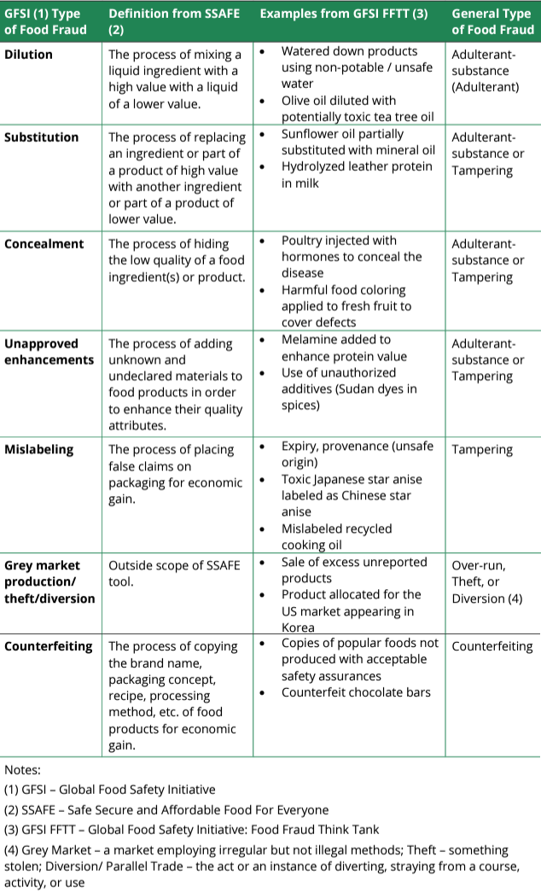
Appendix 1 Types of Food Fraud – Definitions and Examples

  - Methods of Assessment
    - The vulnerability of the supply chain includes consideration of whether the ingredient is a single raw material or an ingredient that is processed by more than one entity and is composed of multiple components.
    - Raw materials, ingredients, packaging materials, and finished products are assessed for vulnerability to food fraud. Methods used for assessments are the likelihood of a food fraud occurring and the potential consequences of food fraud.
      - Likelihood
        - Very Unlikely – Considered to be low risk.
        - Unlikely - Considered to be low risk to medium risk: action is needed with occasional monitoring to mitigate the risk.
        - Fairly Likely - Medium risk: action is needed with occasional monitoring to mitigate the risk.
        - Likely - Medium risk: action is needed with occasional monitoring to mitigate the risk to High risk; urgent action is required, and regular monitoring may be needed.
        - Very Likely / Certain - High risk; urgent action is required, and regular monitoring may be needed.
      - Consequences
        - Negligible - Considered to be low risk.
        - Minor - Considered to be low risk to medium risk: action is needed with occasional monitoring to mitigate the risk.
        - Moderate - Medium risk: action is needed with occasional monitoring to mitigate the risk.
        - Significant - Medium risk: action is needed with occasional monitoring to mitigate the risk to High risk; urgent action is required, and regular monitoring may be needed.
        - Severe - High risk; urgent action is required, and regular monitoring may be needed.
  - Vulnerability Assessment
    - Conduct an assessment of the likelihood that food fraud affects the material:
      - Economic vulnerability (how economically attractive is fraud?)
      - Historical data (has it happened, or are there current developments/cases in the related industry?)
      - Detectability (e.g., how easy to detect, routine screening present?)
      - Access to raw materials, packaging materials, and finished products in the supply chain.
      - Relationship with supplier (e.g., long relationship or spot-buying)
      - Certification through an independent sector-specific control system for fraud and authenticity (e.g., chain of custody certification)
      - Complexity of the supply chain (e.g., length, origins, and where the product is substantially changed/processed)
    - Use tools to develop in setting up an FFVA (e.g., SSAFE or HorizonScan).
    - Address food fraud prevention (or elements thereof) at the business organization level rather than at the site level only, i.e. supply chain mapping, including factors such as socioeconomics, behavioral, geo-political, and historical data.
    - When defining a mitigation strategy, assess the potential vulnerabilities identified for their significance.
    - Consider ISO 31000 as a valuable document when undertaking a risk assessment.
  - Mitigation Plan
    - Develop and document a mitigation strategy for the significant vulnerabilities.
    - The plan is integrated into and supported by the organization’s FSMS for all its products, containing system elements such as training, internal audits, management review, etc., as well as operational control measures, verification activities, corrections, and corrective actions, responsibilities, record keeping, verification activities, and continuous improvement.
    - Ensure Category FII organizations that their suppliers have a food fraud mitigation plan in place.
      - Have suppliers complete a supplier questionnaire confirming whether the supplier has a food fraud mitigation plan in place.
      - Request a copy of the supplier’s food fraud mitigation plan or evidence of the supplier having a GFSI-recognized or approved certification in place.
    - Identify potential mitigation measures for each identified vulnerability.
    - Prevention and Deterrence
      - Supplier Approval Program
      - Approved Materials Program
      - Authenticity Verification
        - Certificate of Analysis (COA)
        - Letter of Guarantee
        - Certificate of Conformance
        - Product Specifications
      - Material Receiving Program
      - Country of Origin
      - Allergen Control Program
      - Authenticity Validation
        - Nutrition Testing
        - Chemistry Testing
        - Isotopic Analysis
        - Volatile substance
        - Sensory Analysis
      - Hazard(s) Testing
        - Biological
        - Chemical
        - Physical
    - Detection
      - Authenticity Validation
        - Nutrition Testing
        - Chemistry Testing
        - FTIR – Fourier Transform Infrared Spectroscopy
        - Nuclear Magnetic Resonance (NMR) Spectroscopy
        - Differential Scanning Calorimetry (DSC)
      - Country of Origin
      - Allergen Control
      - Hazard(s) Testing
        - Biological
        - Chemical
        - Physical
    - Mitigation Strategies
      - Verification activities, such as documents and records analysis, observations and trend analysis are systematically carried out according to the Control Plan.
      - Documentation Verification
        - Raw Material Specifications
        - COA
        - Letter of Guarantee
        - Certificate of Conformance
      - Analytical Surveillance
      - Supplier Relationship
        - Third-party Audits
        - Certifications (GFSI)
      - Supplier Audits
        - The most robust audit strategy is a mature program using direct audits carried on-site at a supplier's facility or facilities by well-qualified auditors. It also includes anti-fraud measures and unannounced audits and is performed at a frequency proportional to vulnerability. The least rigorous audit strategy would be paper audits (or no audit) performed by a third-party without any anti-fraud elements.
  - Review and Verification
    - Review
      - Annual Review of all material vulnerability assessments and when changes to the approved material occur.
    - Verification
      - Verification of material integrity shall be conducted on an as-needed basis or per customer’s requests utilizing the mitigation plan noted above.
  - Records
    - Vulnerability Assessment Records – Shall be maintained by the Quality Department and reassessed annually or when changes to the approved material occur or product specifications or per customer’s request.

- Responsibility
  - All Personnel
    - Adheres to this policy.
  - Food Fraud Prevention Team
    - Carry out the development, implementation, and review of the Product Fraud Mitigation Plan.
    - Create a risk to food safety or non-compliant products.
    - Report to the Senior Management of the Management System.
    - Establish and maintain a continuous management process.
    - Create a supplier verification approval program.
    - Establish best practices for receiving organic ingredients/products.
    - Establish best practices for high-risk imports or products.
    - Establish best practices to ensure traceability and mass balance of the supply chain.
  - Senior Site Management
    - Ensures and verifies this policy and procedure is adhered to;
    - Takes corrective action to ensure compliance with this policy
  - Preventative Control Qualified Individual (PCQI)
    - Visually inspects areas for compliance with this policy.
    - Oversees compliance of procedure.
    - Ensures personnel is trained on this policy and procedures.
    - Monitors and takes corrective action to ensure compliance with this policy.
  - Production Personnel
    - Apply the acquired relevant training.
  - Human Resources
    - Conduct relevant training/s for all personnel.
  - Purchasing/Receiving Personnel
    - Ensure the quality and authenticity of purchased raw materials.
  - Quality Personnel
    - Validate training and adherence to policy and procedure.
    - Monitor and document non-conformance observation, also known as discrepancy, using Corrective and Preventive Action Form.
    - Document control, records, and archive.
    - Monitor the vulnerability assessment(s) and implement the prevention, detection, and mitigation strategies.
    - Maintain Vulnerability Assessment records.
    - Reassess records on an annual basis or when changes to the approved material occur, product specifications, or per customer’s request.

- Corrective Actions
  - In the event of suspected or actual incidences of food fraud in the facility, review and revise the mitigation plan and vulnerability assessment.
  - Re-align the supplier approval process.
  - Re-train all related personnel on this policy.

- Review – Quality
  - There is awareness within the senior management of the need for food fraud vulnerability assessment and mitigation strategies.
  - There is a current, documented vulnerability assessment in place that identifies key ingredient vulnerabilities including the justification for their inclusion. The methodology for selecting the key ingredient vulnerabilities shall be available.
  - The vulnerability assessment shall include an evaluation of the site vulnerabilities including from staff, contractors, and other associates.
  - There are documented mitigation (i.e., prevention) strategies in place for all identified vulnerabilities, which identify what is to be done and who is responsible.
  - The mitigation strategies are active and are being reviewed for effectiveness.
  - The vulnerabilities and mitigation strategies are reviewed at least annually.
  - There are records available of review of the food fraud program.

- History
Revision No.: | Revision Date: | Description of Change: | Originator / Author Name: | Title / Department:
0 | YYYYMMDD | Original | ENTER AUTHOR NAME | ENTER TITLE / ENTER DEPARTMENT

Requirements:
- The trainee (employee/visitor) has read or received a verbal translation of all or part of the policy, procedure, method, and/or SOP for which they are being trained.
- The trainee has observed a demonstration of the task they are to perform or the procedure for which they are being trained as required.
- The trainee has demonstrated the ability to perform the task with acceptable proficiency and minimal supervision.

TRAINEE (Print Name): | TRAINEE (Signature): | Date: | Department:
Trainer / Supervisor (Print Name): | Trainer (Signature): | Date: | Department:

*Should you need assistance in customizing this document please email shop@consultareinc.com

NAME (Print): | Date:

Food Fraud Mitigation Training Material and Comprehensive Quiz

Direction: Choose the best answer and encircle the letter.

- Who carried out the development, implementation, and review of the Product Fraud Mitigation Plan?
- PCQI
- Food Fraud Prevention Team
- Quality Personnel

- Raw materials, ingredients, packaging materials, and finished products are not assessed for vulnerability to food fraud.
- True
- False

- Consider _________ as a valuable document when undertaking a risk assessment.
- ISO 26000
- ISO 27001
- ISO 31000

- It is the process of hiding the low quality of a food ingredient(s) or product.
- Concealment
- Substitution
- Diversion

- Who monitors the vulnerability assessment(s) and implements the prevention, detection, and mitigation strategies?
- Senior Management
- Quality Personnel
- Food Fraud Prevention Team

you need assistance in customizing this document please email shop@consultareinc.com

Comprehensive Quiz: ANSWER KEY

- Who carried out the development, implementation, and review of the Product Fraud Mitigation Plan?
- PCQI
- Food Fraud Prevention Team
- Quality Personnel

- Raw materials, ingredients, packaging materials, and finished products are not assessed for vulnerability to food fraud.
- True
- False

- Consider _________ as a valuable document when undertaking a risk assessment.
- ISO 26000
- ISO 27001
- ISO 31000

- It is the process of hiding the low quality of a food ingredient(s) or product.
- Concealment
- Substitution
- Diversion

- Who monitors the vulnerability assessment(s) and implements the prevention, detection, and mitigation strategies?
- Senior Management
- Quality Personnel
- Food Fraud Prevention Team

